- ASK
  - Problem Overview
Cyclistic is a Chicago-based bike-share company that offers flexible pricing options, including single-ride passes, day passes, and annual memberships. While this pricing structure has helped attract a broad range of riders, Cyclistic’s finance team has identified that annual members are significantly more profitable than casual riders. As a result, the Director of Marketing has identified a strategic priority: increasing the number of annual memberships to support long-term growth and financial sustainability.
The marketing team believes there is strong potential to convert casual riders into annual members, as casual riders are already familiar with Cyclistic’s services and have demonstrated a willingness to use the bikes. However, before designing targeted marketing campaigns, the team must first understand how casual riders and annual members differ in their bike usage behavior. Without this understanding, marketing strategies would rely on assumptions rather than data-driven insights.
The primary business task for this analysis is to examine how annual members and casual riders use Cyclistic bikes differently. By identifying behavioral patterns such as ride duration, frequency, time of day, and weekday versus weekend usage, this analysis aims to provide actionable insights that can guide marketing strategies focused on membership conversion.
To create an effective marketing strategy, the company must first understand a foundational question:
How do annual members and casual riders use Cyclistic bikes differently?
Understanding the behavioral patterns of each group will help tailor campaigns that encourage casual riders to convert into members.

  - Key Stakeholders
Primary Stakeholders:
- Lily Moreno – Director of Marketing and project sponsor
- Cyclistic Marketing Analytics Team – Responsible for data analysis and insights
- Cyclistic Executive Team – Makes the final decision on marketing strategy implementation
Secondary Stakeholders
- Cyclistic customers (casual riders + members) – Whose behavior and preferences are being studied
- Broader Chicago community – Indirectly impacted by improved transportation access

  - Business Task:
The task is to analyze how annual members and casual riders use Cyclistic bikes differently by examining 12 months of historical bike-share trip data. The goal is to identify usage patterns, behavioral trends, and key differences that can inform targeted marketing strategies that encourage casual riders to become annual members.
Understanding customer behavior will help Cyclistic:
- Design targeted marketing campaigns based on real usage trends.
- Identify high-value rider segments who are most likely to convert.
- Improve member-focused benefits by aligning them with actual riding habits.
- Support strategic decisions with data-driven insights rather than assumptions.
This stage sets the foundation for recommendations that will directly influence Cyclistic’s revenue growth strategy.

- PREPARE: Data Collection and Understanding

This analysis uses publicly available historical bike-trip data from Motivate International Inc., as provided in the Cyclistic case study. Specifically, the Divvy 2019 Q1 and Divvy 2020 Q1 datasets were selected, as recommended in the case study instructions, to ensure compatibility with the analysis tools and to accommodate system memory limitations. These datasets contain detailed trip-level records, including ride start and end times, station information, bike type, and user type.
The data is organized into CSV files, with each file representing a quarterly snapshot of bike-share activity. Key variables relevant to the business question include started_at, ended_at, ride_id, and usertype, which distinguishes between subscribers and customers. Importantly, no personally identifiable information (PII) is included, ensuring compliance with data privacy standards and preventing individual riders from being tracked across trips.
To evaluate data credibility, the ROCCC framework was applied. The data is reliable (collected by a reputable bike-share operator), original (first-party operational data), comprehensive (large trip volumes across seasons), current (reflective of modern bike-share usage), and cited through an open data license. Overall, the dataset is well-suited for answering the business question while maintaining ethical and privacy considerations.

- PROCESS: Data Cleaning and Transformation

Before analysis, the data required significant cleaning and standardization. The datasets used different labels for rider types: annual members were labeled “Subscriber,” and casual riders were labeled “Customer.” To align with Cyclistic’s terminology, these values were standardized into a new column labeled member_casual, with “Subscriber” converted to “member” and “Customer” converted to “casual.” This step ensured consistency across datasets and prevented misclassification during analysis.
Additional transformations were applied to prepare the data for analysis. A new column, ride_length, was created by subtracting the ride start time from the ride end time. This value was formatted as a time duration to enable meaningful comparisons of ride lengths across user types. Records with negative or zero ride durations were removed, as these represented data errors or incomplete trips that could skew averages and trends.
A day_of_week column was created using the ride start date to support temporal analysis. The data was checked for null values, duplicates, and formatting inconsistencies. Once cleaned, the datasets were merged into a single master file, providing a unified and analysis-ready dataset that accurately reflects Cyclistic’s bike usage patterns.
Finally, the Divvy 2019 Q1 and 2020 Q1 datasets were successfully merged in BigQuery after resolving schema differences and standardizing data types into a single master table using UNION ALL to append records while preserving full trip history. Derived variables such as ride length, day of week, and start hour were created using timestamp functions. Records with invalid durations were removed to ensure analytical accuracy. The final dataset enabled a comparative analysis of riding behavior between casual riders and annual members.

- ANALYZE: Identifying Trends and Patterns
Descriptive analysis revealed clear behavioral differences between casual riders and annual members. One of the most notable findings was ride duration: casual riders typically took longer rides, suggesting recreational or leisure-focused use. In contrast, annual members took shorter, more frequent rides, indicating functional use such as commuting or running errands. These differences highlight distinct motivations between the two rider groups.
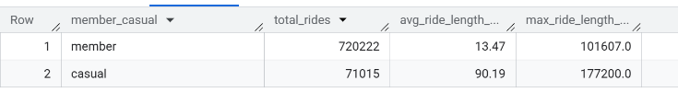
From my SQL query, analysis of ride duration shows that casual riders have a significantly longer average ride length than annual members. This suggests that casual riders primarily use Cyclistic bikes for recreational purposes, while members tend to use the service for shorter, utility-driven trips such as commuting. Also, ridership patterns by day of week reveal that annual members are most active on weekdays, while casual riders peak on weekends. This distinction reinforces the idea that members rely on Cyclistic for regular transportation, whereas casual riders primarily use the service during leisure time.
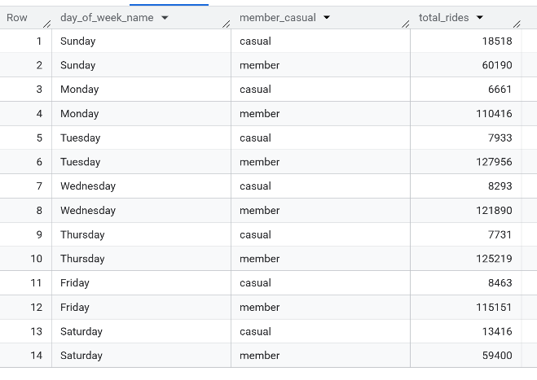
Time-of-day analysis shows that annual members have clear peak usage during morning and evening commute hours, while casual riders tend to ride later in the day. These trends further distinguish functional commuting behavior from recreational usage.
Although casual riders tend to take longer trips, annual members account for a higher volume of rides overall. This indicates consistent engagement and highlights why annual memberships are more profitable for Cyclistic.
The analysis reveals clear behavioral differences between casual riders and annual members. Casual riders tend to take longer, less frequent rides on weekends and during midday hours, suggesting recreational use. In contrast, annual members ride more frequently, particularly on weekdays and during commute hours, indicating reliance on Cyclistic for regular transportation. These distinctions provide valuable insight into how casual riders may be encouraged to transition into membership plans.
- Share Phase: Visualizing Insights (See PowerPoint Presentation)
To communicate findings effectively to Cyclistic’s executive team, multiple visualizations were created. A bar chart comparing average ride length by rider type clearly illustrated that casual riders take longer trips than members. This visualization made the difference immediately apparent and supported the narrative around leisure versus utility usage.
A second visualization—a stacked bar chart showing the number of rides by day of week and rider type—highlighted the weekday dominance of members and the weekend concentration of casual riders. This chart reinforced the idea that commuting behavior is a key differentiator between the two groups. Additionally, a line chart of ride volume by hour of day showed commute-time peaks for members and mid-day peaks for casual riders.
All visualizations were designed with clear labels, consistent color usage, and descriptive titles to ensure accessibility and executive readability. Together, these visuals transformed raw data into a coherent story that directly answers the business question and prepares stakeholders for actionable recommendations.
- ACT Phase: Recommendations and Next Steps.
Based on Cyclistic trip pattern analysis, clear behavioral differences exist between casual riders and annual members. Casual riders take longer rides and are most active on weekends and during midday hours, indicating recreational or leisure-focused use. In contrast, annual members ride more frequently during weekdays and peak commuting hours, suggesting that membership aligns more closely with routine transportation needs. Because casual riders are already engaged with the Cyclistic service, they represent the strongest opportunity for conversion into annual members. The following recommendations are designed to leverage these insights and increase annual membership adoption in measurable, practical ways.
Recommendations:
The first recommendation is to launch weekend-focused membership conversion campaigns. Since casual ridership peaks on Saturdays and Sundays, Cyclistic should run digital campaigns during these high-traffic periods, offering limited-time incentives such as discounted annual memberships, free trials, or bonus ride credits for upgrades. These promotions can be delivered through social media ads (Instagram, TikTok, and Facebook), in-app notifications, and QR codes on docking stations located in popular recreational areas. This strategy targets casual riders when they are most likely to engage with Cyclistic and makes the decision to upgrade feel immediate and rewarding. Success can be measured using weekend membership sign-up rates, campaign click-through rates, and the percentage increase in repeat rides among converted users.
The second recommendation is to implement data-driven prompts for membership after long rides. Because casual riders tend to have longer rides, they are likely to spend more per month on day passes or repeated single-ride purchases. Cyclistic can use automated messaging (email or app notifications) triggered after specific behaviors, such as completing a ride longer than 30 minutes or taking multiple rides in a week, to provide personalized cost-savings prompts. Messages such as “You could have saved $X as a member this month” or “Upgrade now for unlimited 45-minute rides” are effective because they directly connect the rider’s behavior to a financial benefit. This recommendation supports conversion by addressing a key motivator—value and convenience—and can be evaluated using conversion rates following a prompt, membership purchases within 24–48 hours, and engagement metrics such as message open and click rates.
The third recommendation is to strengthen a commuter-focused membership strategy that reinforces the practical value of annual membership. Since member rides peak during weekday commuting hours, Cyclistic should emphasize membership benefits focused on reliability, daily convenience, and predictable costs. Marketing efforts should highlight membership as a “mobility subscription” for commuters through targeted email campaigns, weekday morning ads, and partnerships with employers, colleges, and transit organizations. Cyclistic could also introduce commuter-based loyalty incentives, such as monthly ride streak rewards or discounts for consistent weekday usage. This strategy encourages riders who are already commuting or likely to commute to view the annual plan as a long-term cost-saving solution. Success metrics may include increased weekday membership sign-ups, higher weekday ride volume, and improved retention/renewal rates among new members.

Conclusion:
In conclusion, Cyclistic can increase annual memberships by aligning its marketing approach with real rider behaviors. Weekend conversion campaigns can target casual riders when engagement is highest, cost-saving prompts can convert long-ride users by emphasizing membership value, and commuter-focused messaging can reinforce the benefits that drive annual membership profitability. Together, these strategies create a data-supported pathway to convert casual riders into members and support Cyclistic’s long-term business growth.

